## Diabetic Retinopathy Classification Using Deep Learning Techniques

## Project code

### ZN-CS-2025-146

## Project Advisors

### Dr Hassam Ali (Internal)

### Dr Muhammad Fayyaz (External)

## Project Manager

### Prof. Dr Muhammad Ilyas

## Project Team

### Member 1: Zarnain Javed (Group Leader)

### Roll no: BSCS51F22S022

### Member 2: Narmeen Ayub

### Roll no: BSCS51F22S011

### **Submission Date**

### Oct 6th, 2025

**Table of Contents**

1. Abstract 3

2. Background and Justification 3

3. Research Tentative Methodology 4

4. Project Scope 5

6. References 7

**Diabetic Retinopathy Classification Using Deep Learning Techniques**

# Abstract

Diabetic Retinopathy (DR) is a leading cause of vision impairment worldwide, demanding timely diagnosis. While deep learning has achieved promising accuracy in DR detection, severe class imbalance, fine-grained stage discrimination challenges, and inconsistent performance across varying image quality hinder clinical deployment. This project proposes a hybrid CNN framework with dual-attention mechanisms (Global and Category Attention Blocks) to improve multi-stage DR classification. A module will be introduced to focus on clinically significant lesions (microaneurysms, exudates, hemorrhages). To mitigate data imbalance at the architecture level, the framework integrates channel and spatial attention modules rather than relying on traditional oversampling techniques, ensuring robust performance across all DR severity levels. This combination will provide interpretable outputs that can assist ophthalmologists in clinical decision making.

##### The objectives are:

* 1. To develop a lightweight and efficient hybrid CNN architecture with dual-attention mechanisms (Global and Category Attention Blocks) for accurate multi-stage diabetic retinopathy classification.
  2. To incorporate a mechanism for lesion-localized model interpretability.

#### To eliminate class imbalance in DR datasets through architecture-level improvements rather than oversampling techniques.

#### To validate the model on benchmark datasets like APTOS and EyePACS using robust performance metrics and explanability analysis through Grad-CAM and attention heatmaps for increased clinical trust.

The expected outcome is an explainable, clinically reliable, and lightweight model deployable in real-time DR screening, especially in low-resource settings.

# Background and Justification

* **Problem:**

Diabetic Retinopathy grading suffers from severe class imbalance, with the majority of retinal fundus images belonging to the "No DR" category, resulting in biased and unreliable automated detection systems. Current CNN-based systems (DenseNet, EfficientNet, MobileNet with attention) achieve strong accuracy but still:

* Fail in under-represented classes (mild, moderate DR).
* Provide weak clinical interpretability (black-box outputs).
* Inconsistent performance across varying image quality levels

##### Gap in Literature:

* + Dual-attention CNNs (e.g., GAB + CAB) improve imbalance handling but remain single-modal.
  + Existing architectures struggle with fine-grained discrimination between adjacent DR severity stages due to subtle visual differences.
  + Few works focus on lightweight, efficient models deployable in low-resource clinical settings while maintaining high accuracy and interpretability.
  + Most approaches rely on data augmentation or oversampling rather than architecture-level solutions for addressing class imbalance.

##### Justification:

This research fills the gap by combining dual-attention mechanisms, architecture-level imbalance handling, and knowledge-guided attention to deliver an interpretable, generalizable DR classifier.

# Research Tentative Methodology

##### Proposed Methodology

##### The proposed methodology for multi-stage Diabetic Retinopathy (DR) classification consists of three main phases:

**Step 1**: Dataset Preparation

* Datasets: APTOS (3,669 images) + EyePACS (35,000 images).
* Preprocessing: Rescaling , CLAHE, normalization.
* Augmentation: Flips, rotations for class balancing and dataset diversity.
* Super-Resolution Enhancement: Apply SRGAN to enhance low resolution fundus images, improving visibility.

**Step 2**: Model Design

* Feature Extraction: Use VGG54 as the backbone CNN to extract features from fundus images.
* Attention Modules: Channel and Spatial attention modules will be used to extract more important features.
* Fusion: Combination of outputs from multiple layers of CNN.
* Lightweight Optimization: Model efficiency will be improved using knowledge transfer and compression, creating smaller, faster versions for deployment.

**Step 3:** Training &Evaluation

* Datasets: Training and testing on public fundus datasets such as EyePACS and APTOS.
* Metrics: Accuracy, Sensitivity, Specificity
* Optimizer: Adam(Adaptive Moment Estimation), learning rate schedule.
* Explainability: Grad-CAM and lesion-specific saliency maps are used to highlight critical retinal regions influencing predictions.

**Step 4**: Validation

* Cross-dataset evaluation (train on APTOS, test on EyePACS, and vice versa).
* Comparison with existing methods (CbaselineCNNs, single-attention, and hybrid models for improvements).

# Project Scope

##### In Scope:

* Multi-stage DR classification.
* Attention-guided lesion interpretability.
* Validation on APTOS &EyePACS datasets.

**Out of Scope:**

* Clinical deployment in hospitals (prototype only).
* Real-time lesion segmentation/localization.
* Integration with telemedicine platforms (future work).
* To make it multi-model with metadata integration.

# High Level Project Plan

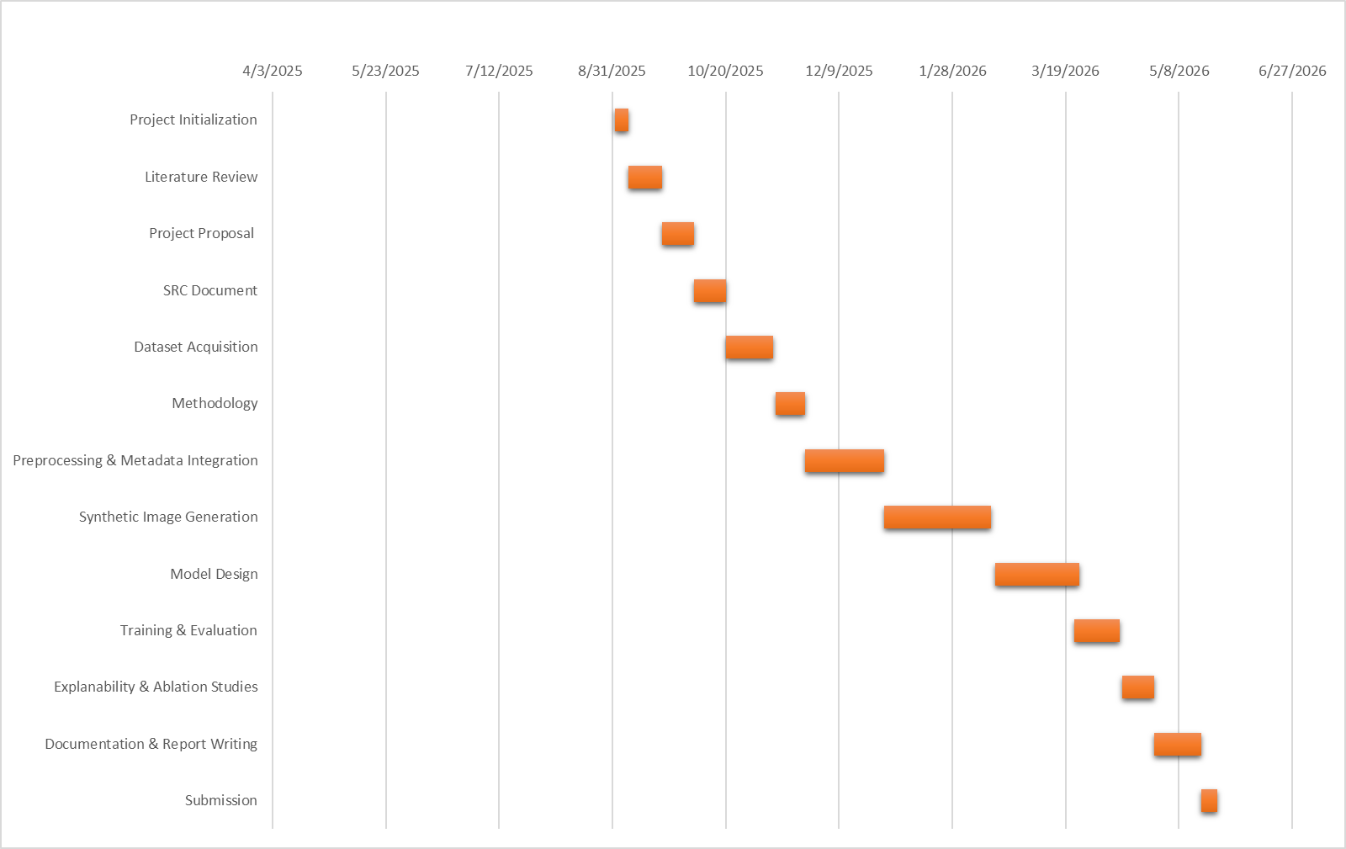

Fig: Gantt Chart